**Patient History Form**

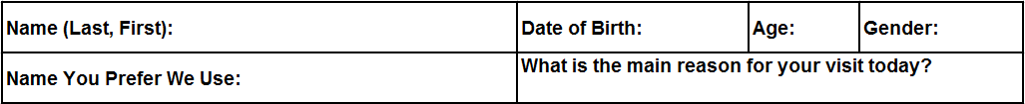

Thank you for completing the sections below. This information gives your provider a complete picture of your health status in order to partner with you in your care needs.

**Personal Medical History**

Do you now have or have you had in the past any of the following conditions?

(Please circle ‘Yes’ or ‘No’ as appropriate)

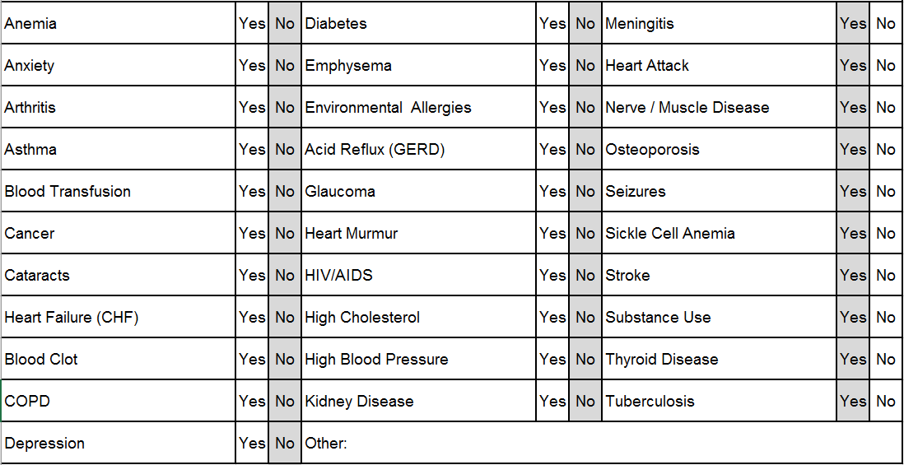

**Surgical History**

Have you had any of these surgeries or procedures?

(Please circle ‘Yes’ or ‘No’ as appropriate)

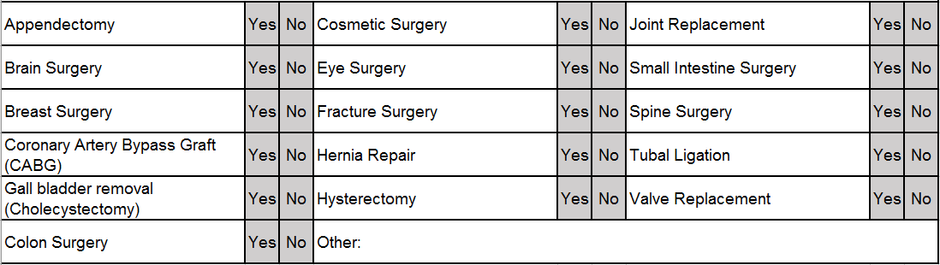

**Social History**

Do you or have you used alcohol, drugs or tobacco? Are you sexually active?

(Please circle ‘Yes’ or ‘No’ and fill out the type/amount as appropriate)



**FAMILY HISTORY**

**Are you adopted? □ No □ Yes**

If adopted and you do not know the health history of your biological relatives, please skip the Family History section below.



As best you can, mark which relative has had the following diseases. The health history of your parents, brothers and sisters is the most important.