Provider Remote Access
Accessing Epic and other applications remotely
SWR Clinical INformatics
2016
  - Index
How to get Remote Access 2
General Security 2
Patient Confidentiality, Internet Usage and Electronic Mail Usage Policies 2
What are SSL/APPS/Haiku/Canto/Mobile Device Access? 3
APPS – 3
SSL – 3
Haiku and Canto 3
Mobile Device Access 3
Setting up a Device for Remote Access 4
Citrix Receiver 4
Windows machines (XP, Vista, Win 7) 4
Windows 8/10 – 4
Non-Microsoft 4
Macs – 4
IOS – 5
Android – 6
Haiku / Canto Access Instructions – 6
Android Devices – Haiku 8
Mobile Data Access 9
Logging on to APPS 10
Getting Started: SSL VPN 11
Install applications needed for Remote Access 11
Install Java 11
Install Juniper Pulse 11
Setting up Citrix Receiver for Remote Access 15
Logging into the SSL VPN 16
Epic Access 17
Logging out of the VPN 18
Remote Desktop Protocol (RDP) 19
Troubleshooting Problems 20
APPS Troubleshooting 20
Windows XP/Vista/7 – Internet Explorer 11 Compatibility 20
Misc Windows 21
SSL Troubleshooting 21
IOS/Android Troubleshooting 21

How to get Remote Access
To access Providence systems remotely, you need Internet access, a Providence network account and Remote Access to be enabled. Remote Access can be device specific. If you get it working on one device it may not work on another. Each device may need some individual configuration.

These instructions are intended to provide assistance setting up remote access in the simplest way possible for providers. Most providers will only need to install Citrix Receiver and go use APPS. You’ll most likely know what additional access you need so you can complete only what is necessary and if you don’t know, call for assistance.

If you are having issues accessing Epic you can call:
Olympia: (360) 493-7000
Centralia: (360) 330-8888
Epic Service Desk: 855-526-4188

General Security
You are responsible for protecting the authentication factors entrusted to you.
Keep your Providence network password secret.
If an unauthorized person learns your username/password, this person can assume your identity. Any action this intruder takes is attributed to you in the system’s security log.
For your own protection and that of the system, always take the following precautions:
- Never reveal your password to anyone. Do not write it down.
- If you think someone has learned your username, password, notify Provider Support Line, who will verify your identity (may be required to show identification) and request your account be reset immediately. At your next login you will have to create a new password or PIN.
- Do not let anyone access the system under your identity (i.e. username and password or PIN).
It is essential to site security that you follow standard logoff procedures. Failure to log off properly can create a route into the system that is completely unprotected.

Patient Confidentiality, Internet Usage and Electronic Mail Usage Policies
Just a reminder of the requirement to comply with all applicable laws and regulations, as well as PH&S policies on Patient Confidentiality regarding all information accessed via the VPN.

What are SSL/APPS/Haiku/Canto/Mobile Device Access?
If you have been granted access to Providence networks remotely, there are several different ways of connecting using the same login and password. Each has benefits over the other in certain circumstances.
APPS – CitrixTM Virtual Applications are secure access to Epic and some other applications within Providence. Requires two (2) logins to get to Epic (Citrix Gateway and Epic) https://apps.providence.org
A virtual app provides a secure encrypted method of accessing resources without much network/CPU overhead since the work is done by the server. Nothing is written to the local hard drive. CitrixTM Virtual Applications work on almost any platform, including IOS or Android. It is known as Citrix Receiver most often.
The main drawback for APPS access is that ONLY applications published to the user’s profile are accessible. Usually, that only includes Epic and applications directly related. Internal Providence websites are not available as they are on SSL.
SSL – This includes two similar methods of connecting remotely. Junos Pulse is required for both methods.
First, the legacy method for Providence Remote Access. This will allow you to get to internal websites with one login. But it requires three (3) logins to get to Epic (SSLVPN, Citrix Gateway and Epic) and requires a VPN application called Junos Pulse to be installed.
This uses SSL browser protocols to authenticate and a third party VPN application to establish a VPN tunnel for secure access to Providence over the internet. The third party application is called Junos Pulse and must be installed before the VPN will work correctly for all access. However, since there is already a secure browser connection just logging into https://ssl.providence.org/wamd within a browser will allow some internal Providence websites to be secure and will work without Junos Pulse installed.
Second, just using Junos Pulse. This uses just the VPN application to create a secure tunnel to Providence network. No browser is needed. This still allows application access like Outlook and some medical applications like McKesson Cardiology.
Haiku and Canto
Haiku and Canto are mobile apps that Epic has created for certain relatively narrow functions. They are Epic branded apps and not Providence.
Haiku is optimized for mobile phone use in that it has a small display and can run on a mobile network. Canto use optimized for tablets. Both are available in the Apple® App Store TM or Google Play Store. Both allow users to insert images into patient’s charts and allow read only access to many functions.
Mobile Device Access

Mobile Device Access describes an agreement that Providence requires caregivers to sign if they are going to have devices that could contain Personal Health Information (PHI) for patients. This includes Providence laptops and personal devices with Providence email.

Setting up a Device for Remote Access
All providers will need software installed in order to access remotely. If you’re going to access Epic you will need Citrix Receiver on desktops and laptops. If you are using a mobile device you may need Citrix Receiver, Haiku or Cantos depending on the purpose.

Please check the Citrix website for the download at https://www.citrix.com/downloads.html If a newer version doesn’t work, we’ll post a version on our website that does work.

These instructions are greatly summarizing the setup below but for many who are familiar with their devices this should be adequate. Due to changes in Operating System parameters, very specific directions become outdated quickly. If you spot an error or a change, please alert us so that we may correct it. Email us at SWRProviderLiaisons@providence.org

Citrix Receiver
Windows machines (XP, Vista, Win 7)
- Go to the Citrix website and download the Citrix Receiver for Windows.
- This should be the only thing you have to install to get access to Epic and images (PACS).
- Reboot and go to apps.providence.org on your browser.
- Different browsers can behave differently. If you are having issues with one browser or another check the Troubleshooting section.
Windows 8/10 – There are two ways to get Citrix working on Windows 8/10 PC’s/Tablets
- Mostly the same way as with Windows 7 PC’s. Install and use a browser to access. Common.
- Setup like an app. This means you’ll use the Citrix Receiver app and not use a browser.
  - Once installed, you have to use the Start screen or the tray icon to start Citrix Receiver. The icon will show in the Start Menu once you have installed Citrix Receiver or in the lower right hand corner.
  - Choose apps.providence.org as the server (not email address)
  - Use PHSWA\username as the domain\login combo and Providence AD password (same as Epic)
  - Add at least the Hyperspace Production WAMT from bottom of screen. (Sweep up or scroll if you don’t see the option.)
    - Add other icons or apps as needed (such as Muse or MS Remote Desktop)
  - It will automatically bring these icons up every time it starts.
  - You will need to use the Start Screen to start Citrix Receiver, not your browser.

WARNING! The following are not “officially” supported. We offer best effort support only. ☹

Non-Microsoft
Macs –
- You usually can’t use a browser to login to Epic. You have to use the Citrix Application.
- Go to the Citrix website http://www.citrix.com and download the Citrix Receiver for Macs.
- Java needs to be updated. Go to http://www.java.com to update.
- Look for the Citrix app at the top of the screen. It has a grey icon and looks like this -->
  - The install for Citrix looks similar and may be on the desktop but will not start Citrix, only install.
- When clicking on the app icon it prompts to “Open” or “Preferences” for the first two options.
  - Click Preferences.
- Click on the Accounts tab.
- Click on the + button to add an account.
- Fill out the information.
  - Server: apps.providence.org
  - Login: phswa\username (That’s domain\username)
  - Usual Password.
  - It will always fail once while setting up meaning you’ll have to enter you information twice while setting it up.
  - If it prompts for server type choose Gateway and Enterprise Gateway (Should not prompt)
IOS –
- Download Citrix Receiver for IOS from Apple Apps Store: Citrix Receiver
- Open Citrix Receiver and choose Manual Options
- Choose apps.providence.org as the server (not email address)
- Use PHSWA\username as the domain\login combo and Providence AD password (same as Epic)
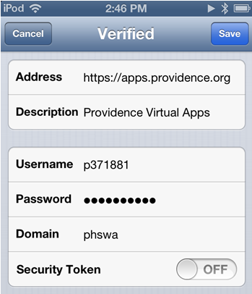
- Add at least the Hyperspace Production WAMT from bottom of screen. (Sweep up if you don’t see the option.)
  - Add other icons or apps as needed (such as Muse)
- It will automatically bring these icons up every time it starts.
- If you don’t see how to start typing, tap once and you’ll see a small rectangle with six boxes. Tap that and you’ll have options for Close, Arrow, Get Help, Home, Keyboard or Mouse. 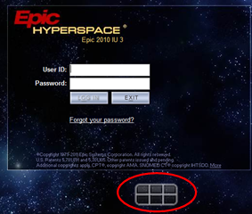

Android –
- Download Citrix Receiver for Android from the Google Play Store: Citrix Receiver
- Choose apps.providence.org as the server (not email address)
- Use PHSWA\username as the domain\login combo and Providence AD password (same as Epic)
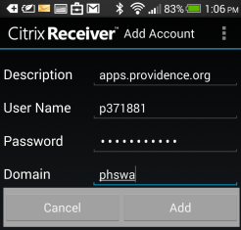
- Add at least the Hyperspace Production WAMT from bottom of screen. (Sweep up if you don’t see the option.)
  - Add other icons or apps as needed (such as Muse)
- It will automatically bring these icons up every time it starts.
- If you don’t see the onscreen keyboard, there should be a triangle button at the top. Clicking the triangle button provides options, including accessing the keyboard.
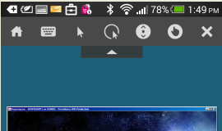
Haiku / Canto Access Instructions –
Minimum Requirements to run Haiku or Canto

Application
Haiku on iOS | Requires iOS 7.0 or later. Compatible with iPhone, iPad, and iPod touch. Optimized for  iPhone 5 or later.
Haiku on Android | Requires Android 3.0 or later.
Canto on iPad | Requires iOS 7.0 or later. Compatible with iPad.

- Download Haiku or Canto to your device from the appropriate Apps store.
To find the application in the App Store, search for “Epic Haiku” or “Epic Canto.” You can also find it in the Medical category.
App | Devices supported | App Store
Haiku | iPhone or iPod Touch | Apple Apps Store
 | Android SmartPhone | Google Play
Canto | iPad | Apple Apps Store

- Obtain the Install ID for your device (40 characters alphanumeric). Apple Devices – Haiku or Canto (note: Haiku screenshots are shown below, but same process works for Canto)
  - Open Haiku or Canto. Accept the License Agreement, if it appears.
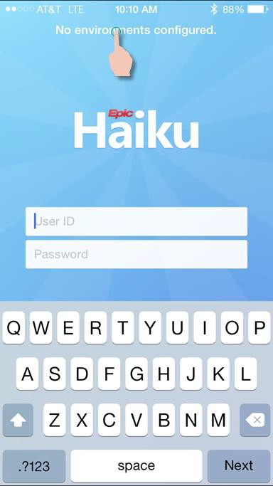
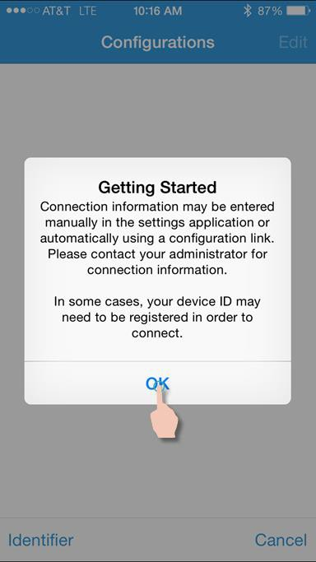
  - Tap No environments configured at the top of the application. If the Getting Started message appears, tap OK.

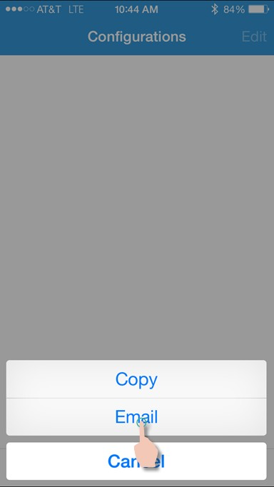
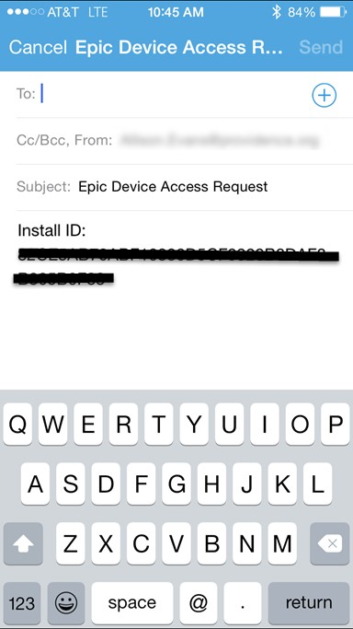
- Tap Identifier (lower left-hand of screen), and then click Email. The Install ID will appear in an email message. Either write this ID down or send it to your email address.

Android Devices – Haiku
- Open Haiku. Click the Menu button (usually 3 vertical dots) and then tap the Settings button. This will display the Haiku setup screen. Tap About and then Device ID.
- The Device ID section will open, displaying the Install ID and Device ID (deprecated). You can choose to E-Mail the IDs to yourself or just take note of the Install ID.
NOTE: The Install ID is 40 characters and may wrap on your screen.
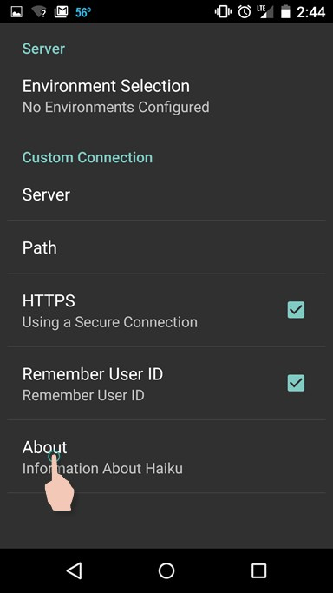
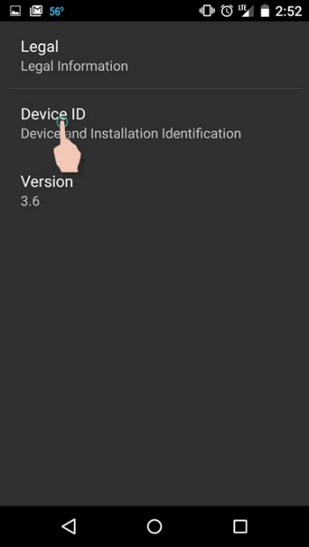
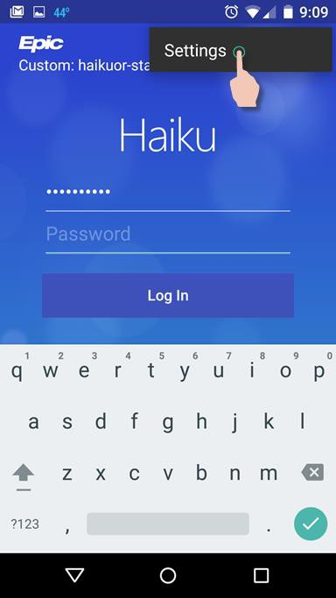

- The Device ID section will open, displaying the Install ID and Device ID (deprecated). You can choose to E-Mail the IDs to yourself or just take note of the Install ID.
NOTE: The Install ID is 40 characters and may wrap on your screen.
- Request access to Haiku or Canto.
Submit an ITSM work order with the Help Desk. Please make sure to include your Install ID, Primary Epic, Login Department, and your Epic User ID when requesting access.
- Configure your device.
Open your device’s Settings application and select Haiku or Canto (iPad). Make sure that Haiku or Canto has access to your Camera.
Set your Connection Settings as follows (same settings for Haiku and Canto):

HTTPS On
Washington and Montana: haikuwa.providence.org
Path Haiku
- iPhone/iPod Touch – Haiku settings: Android – Haiku Settings:
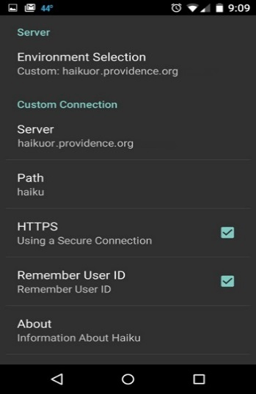
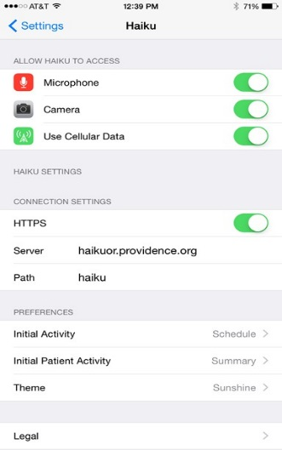
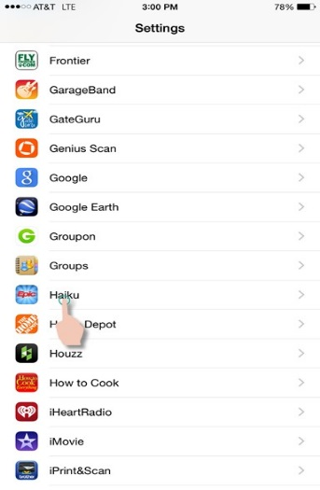

- iPad – Canto settings:
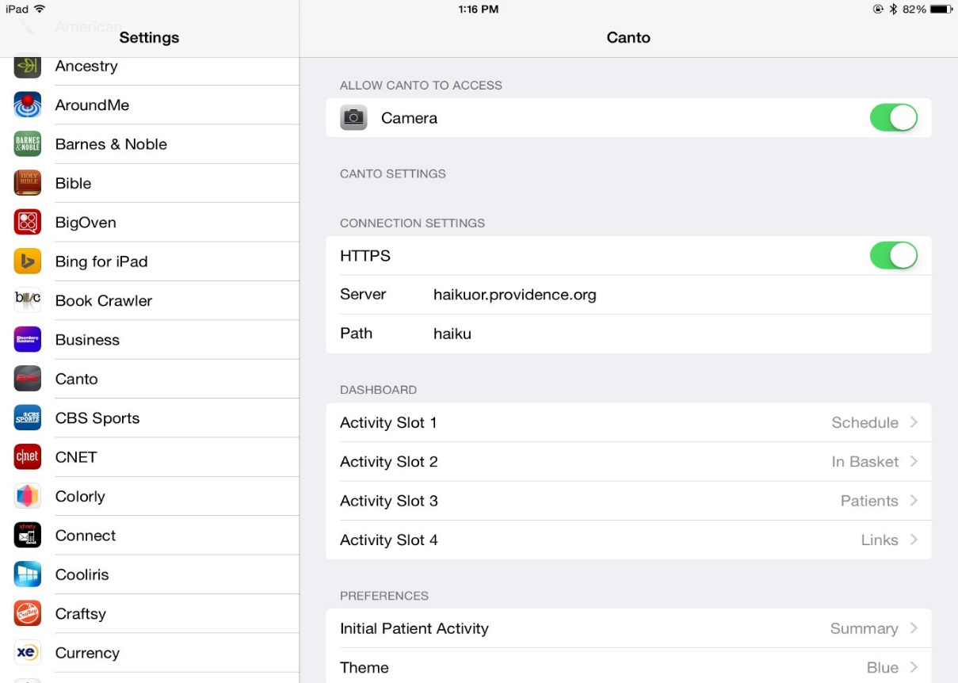

- Log into the Haiku/Canto.
  - Once your access request is completed and your device is configured, you should be able to log in to Haiku or Canto. To do so, open the app and enter your Epic User ID and password.

Mobile Data Access
Mobile data access agreement has to be in place before you can have a Providence laptop or have Providence email on your phone or mobile device. It can be requested by Clinical Informatics or the manager of the department where you work at Providence.

- First, you have to print out the Mobile Device User Agreement (link if you have electronic version), read it and sign it.
  - For providers, does not require managerial signature but for all other employees it does.
- Scanned in to the manager or clinical informatics. Typically, just deliver it to them and they will scan it.
- A Service Catalog Request must be made on your behalf and the agreement attached.
  - It usually takes several days before it is processed.

Logging on to APPS
Once you have Citrix Receiver installed on Windows XP, Vista and 7 or on Macs do not attempt to configure in order to access Epic. To access the Providence Citrix Access Gateway, you can login using Internet Explorer 7, 8, 9 or 10, Google Chrome or Mozilla Firefox. For all others, including Windows 8, iOS and Android, you should open the specific Application not the browser (but it works nearly the same after that.)
Simply type “apps.providence.org” into the Address bar of the browser (without the quotes.) and press enter. This will not work if you type it into the Search bar.
Login using your Active Directory login, which is the same as your Epic login.
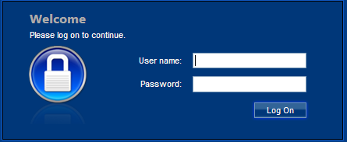
Select Hyperspace Production WAMT.
And login as you normally would login to Epic.
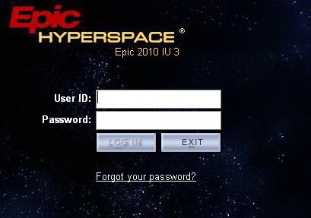

Getting Started: SSL VPN
What is required for Remote Access? Java and Juniper Pulse are required for VPN access.
Start with Setting up the Computer SSL VPN access is PC specific. You will have to setup each device separately.

Install applications needed for Remote Access

Install Java
- Go to the website www.java.com and follow the instructions there.

Install Juniper Pulse
- Launch the website. (https://ssl.providence.org/WAMD or https://ssl2.providence.org/WAMD)
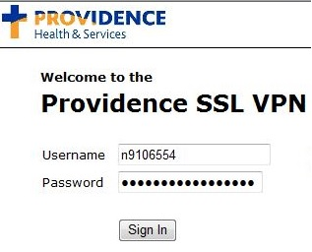
2. The host checker scans the PC to determine if the Juniper software is installed. If not detected, it will prompt to install.(Note: Depending on which version of Internet explorer the user has the install window will look different)

OR

3. There will be a couple of items that will need to be installed, make sure to install all prompts.

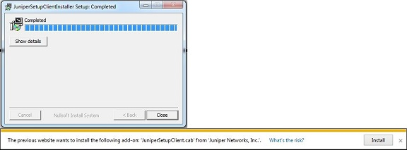

4. After the installation of all items is complete it will prompt again to allow the add-on to run. Select Always Allow either from the drop down arrow to the left of allow or on the main prompt window.
5. Once all of that has been completed the PC will need to be restarted fully.

6. Log back into the SSL website, another Host Checker window should pop up. Select Always Allow.
(Note: A second Security Window may pop up. Check: Do not show again then Allow)

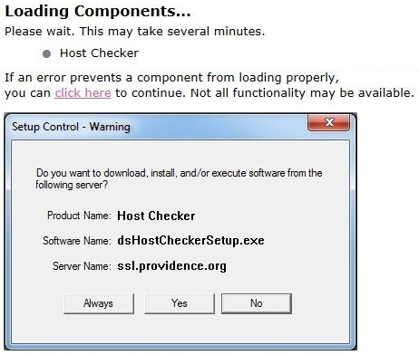

7. Now the set up should be complete however it will not load if the user has Java update 7.51 or higher. A Java Security Exception will need to be added.
(Note: Make sure to write down the URL of the page when it’s sitting at the below screenshot)
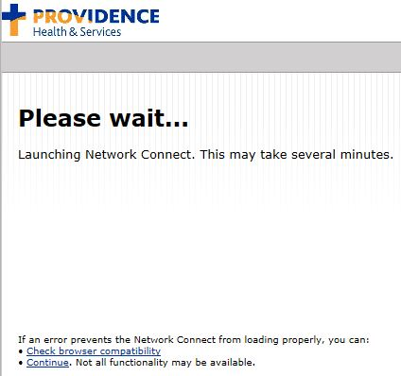

8. Launch Java, Click the Security Tab, Click Edit Site List.

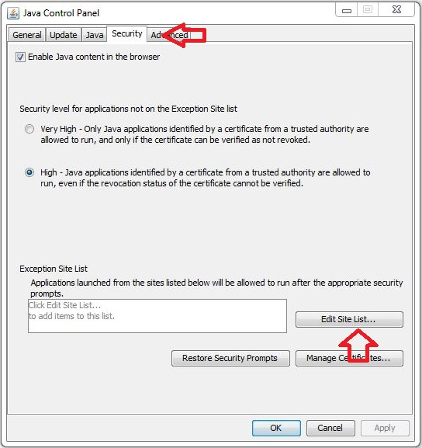

9. Click the Add button, input the base URL.
(Eg. https://ssl.providence.org or https://ssl2.providence.org)

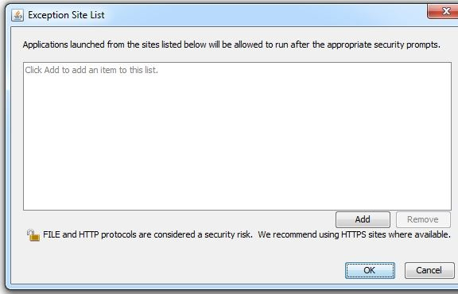

10. Now click the Add button again, and input the specific URL noted in step 7.

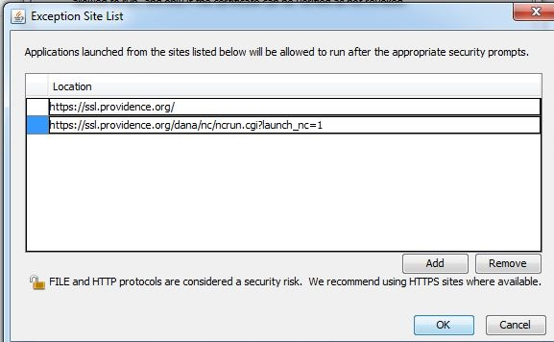

11. If the user is using Internet Explorer you will want to add Providence.org to compatibility view settings.

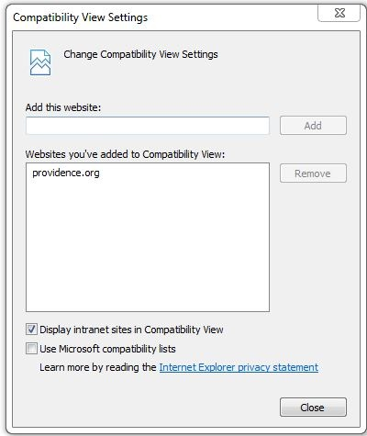

12. Finally restart the PC fully once more.

13. Have the user log back into the SSL VPN site.
(Note: It’s possible the user may receive a session in progress warning just have them click Continue the Session)

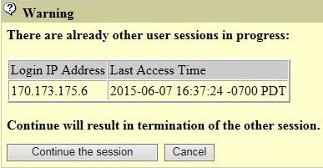

14. Once complete a start menu icon for Juniper should be available if the user would prefer to use the desktop version of the software rather than going through the website.

Mobile Device User Agreement

Setting up Citrix Receiver for Remote Access
Setting up Citrix Receiver for SSL VPN is the same as for APPS access.
See above instructions: Citrix Receiver

Logging into the SSL VPN
- Open the website, https://ssl.providence.org/wamd
- To log into the system, use your Providence Active Directory login. This login is the same as your Epic Login or the login that is used to login to Providence PC’s.
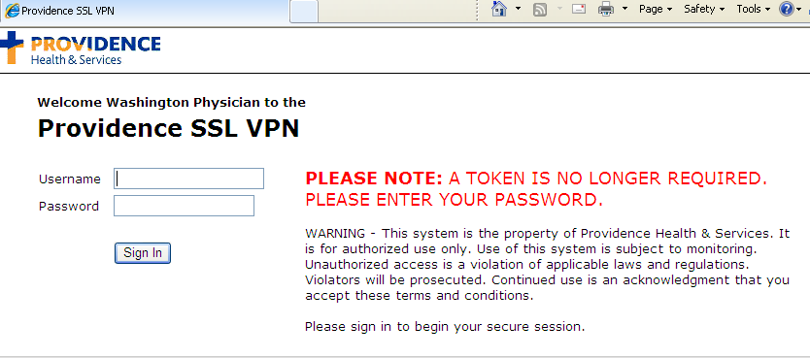
Network Connect will launch and a new icon will appear in the icon tray area of your screen.
You are now connected to the Providence network.
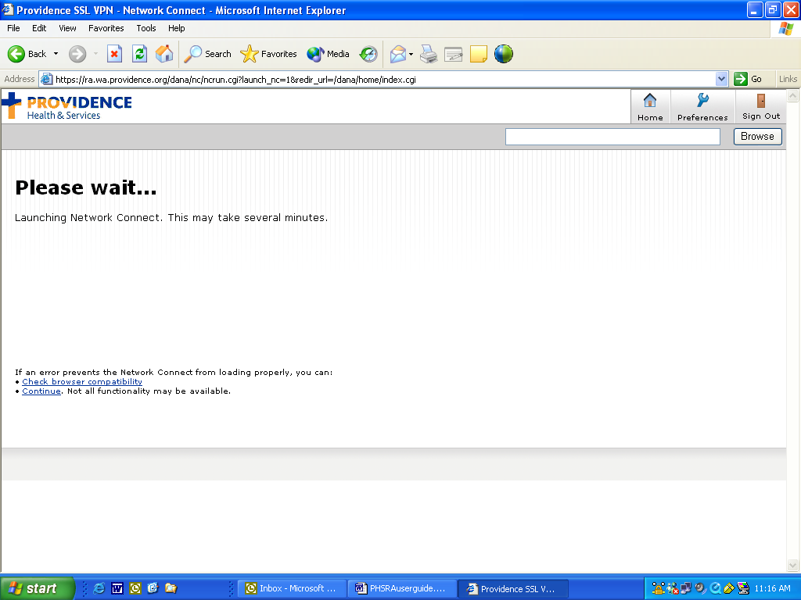

You will be brought to the Providence SSL VPN Physician Portal web page.
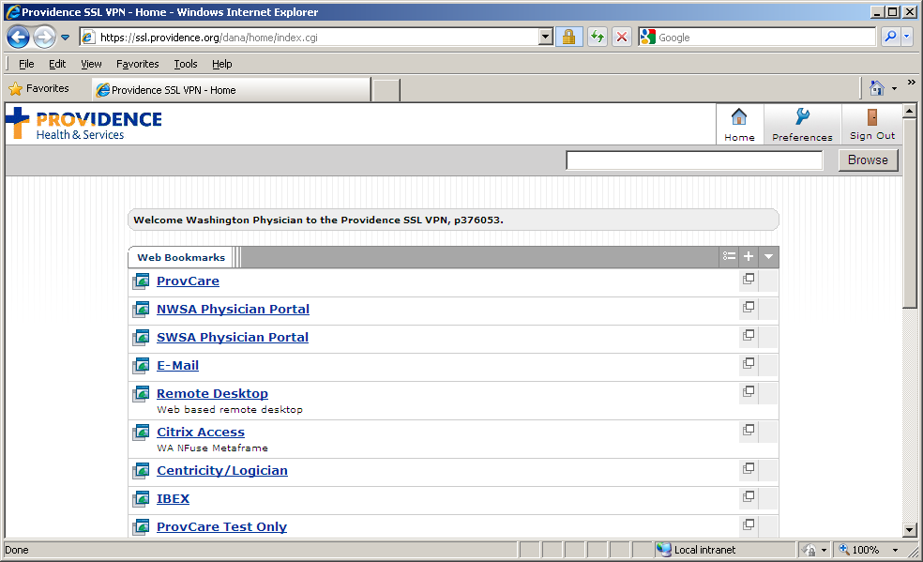
Click on the links to open windows into the available applications.

Epic Access
To access Epic Hyperspace, Click on Citrix Access – WA NFuse Metaframe.
The Username and Password are the same.
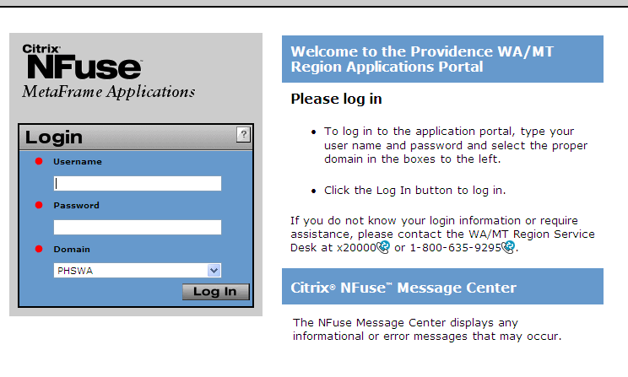

Click on the Hyperspace Production WAMT icon.
The Username and Password are the same. The Epic window should appear after logon.
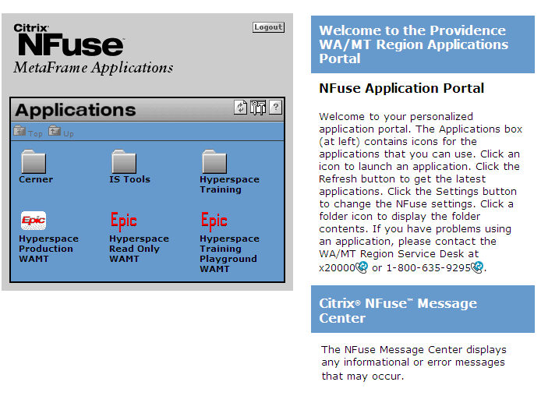

Logging out of the VPN
In order to properly log out of the VPN, either select sign out located on the top right corner of the page OR right click on the Network Connect icon and select sign out.

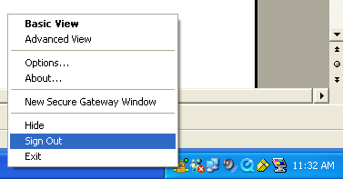
When you are signed out, the Network Connect icon will disappear from your icon tray area.

Remote Desktop Protocol (RDP)
You need to know the name of the PC at the facility and the PC needs to be powered on. The name appears in the bottom right corner of the desktop display when you are logged into the PC.

To remotely access your PC, click the Remote Desktop link on the Physician Portal page. The following screen will appear. (You may see a message asking you to install an Active X component to enable this type of access. If it has been installed, you will be able to enter your facility PC’s name.)
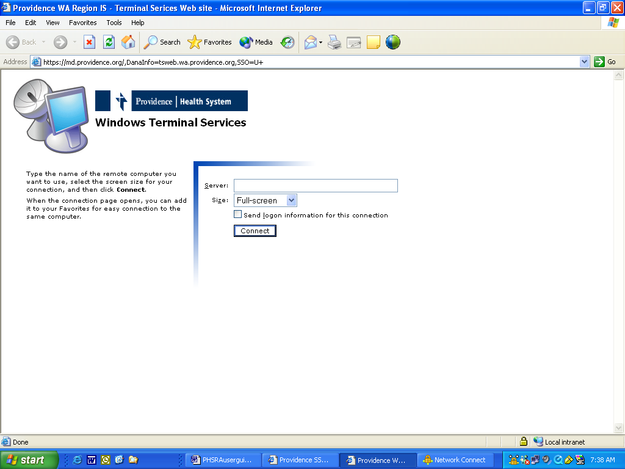

After you enter the PC name and click Connect, you will be prompted to login. Enter your network ID and password and click OK.
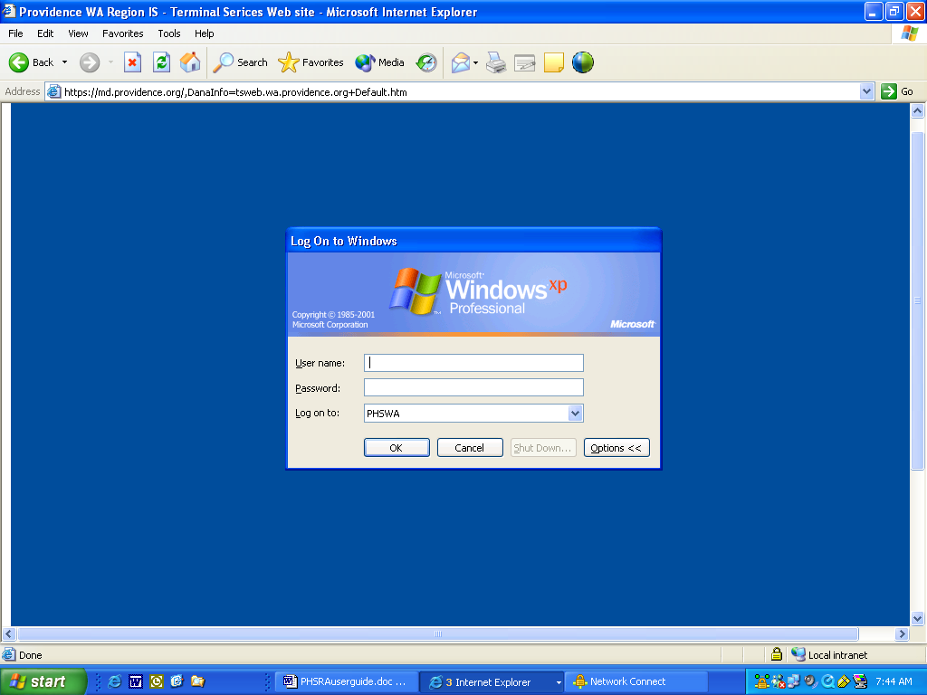

Troubleshooting Problems

APPS Troubleshooting

Windows XP/Vista/7 – Internet Explorer 11 Compatibility
Microsoft released a new update to Internet Explorer in Windows Vista, Windows 7 and Windows 8 operating systems that is preventing users from accessing Epic remotely. Here is a simple fix.

- Open Internet Explorer (IE). Make sure you have IE 11.
  - Click on the Help menu to see what version of Internet Explorer you currently have.
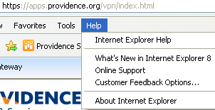

(This one is IE 8 but it would be similar for IE 11.)

- Click Tools - > Compatibility View Settings
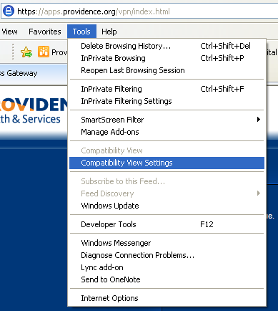
- Add “providence.org” and click Add.
  - It will show in the “Websites you’ve added to Compatibility View:”
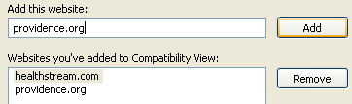

Misc Windows
Updates to Windows and other applications often will cause compatibility problems. Uninstalling the updates will often fix the problem. If that isn’t an option or you need assistance, call the Provider Support Line.
Toolbars can cause problems. Disabling toolbars will sometimes help but uninstalling toolbars is sometimes necessary.

SSL Troubleshooting
The SSL VPN method of accessing remote data is still valid but is more of a legacy method of accessing patient data. Because it is an older method of connecting it is relatively affected by newer technology. Updates to the Windows Operating System and Internet Explorer have a greater effect. The VPN client “Juniper Network Connect” is made for a certain version of Windows with a certain version of Internet Explorer.
The positive side is that it will allow you to reach more resources at Providence. You can access ProvCare, OnCall Online and internal websites that are not accessible via APPS.
If you’re having trouble using SSL VPN on a Windows machine, you may need to uninstall updates to Internet Explorer.

IOS/Android Troubleshooting
If you are having trouble accessing APPS on an iPhone/iPod/iPad then you may have gotten the wrong type of server set when you tried connecting. It is no fault of the user but something that does happen.

To Fix:
- Click the Options button at the bottom of the screen where you input the server address.
- Then fill in the address, description, set Access Gateway and Enterprise Edition.
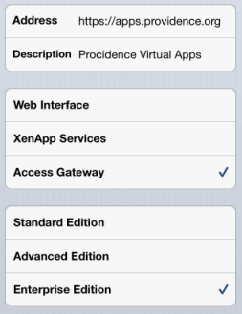
- Fill out the rest (username, password and domain) just as instructed in the original instructions.

